1. Source Code

view- latihan2.php -> application/views

Model1.php -> application/model

Latihan1.php -> application/controllers

Latihan2.php -> application/controllers

1. URL

<http://localhost/pustakabooking/index.php/Latihan1/penjumlahan/10/10>

<http://localhost/pustakabooking/index.php/Latihan2/penjumlahan/10/10>

1. Capture Output program

* Latihan 1
* 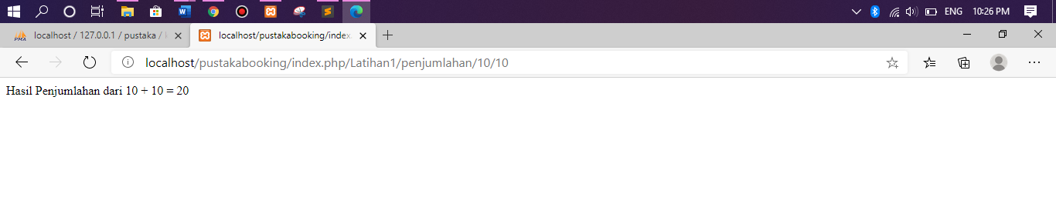Latihan 2

